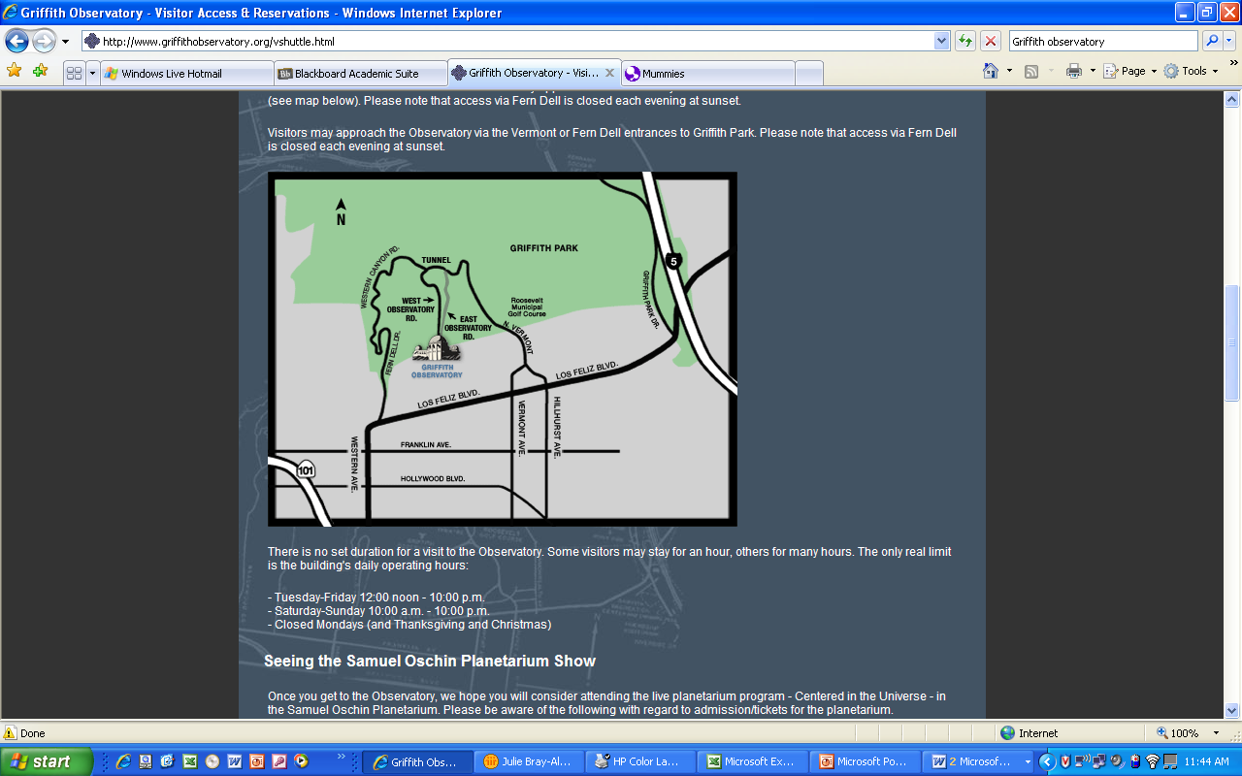***Astronomy Field Trip to the***

**Griffith Observatory**

(http://www.griffithobs.org)

Directions to the Griffith Observatory are at right; floor plan is below; see the web site for PARKING (NEW), planetarium shows and other information.

While there **you must visit the exhibits in the museum and watch any of the three planetarium shows.** The Observatory’s Samuel Oschin Planetarium has three different shows; BE SURE you’re there for the right time! Showtimes are on the web site. See below* for the instructions on your written report.



* After your visit (in either case), TYPE UP a 1-3 page report (DO NOT simply hand-write your responses to the following questions on that sheet!) on your experience based on the questions that follow. **Please attach your planetarium ticket and a picture of yourself as specified below!** BE CAREFUL – failure to follow the directions results in lower points; DO NOT PLAGIARIZE.

PRINT OUT ***or*** EMAIL your packet to me by the beginning of your LAST CLASS (June 7th, NOT Final Exam Day)!

**Name: _______________**

**Griffith Observatory Report – Questions to Address**

**(Please expand this Word doc and type your answers under the questions)**

***Hall of the Sky***:

A. Comment in your own words what you saw in this display. Did you find any current sunspots? Draw a picture of the sun on the day of your visit (look through the solar telescope)!

***Hall of the Eye***:

A. Find the oldest telescope they have on display and write about it in your own words.

B. Look at the infrared camera. Which color represent hotter / cooler? Which part of your face is lower in temperature, and why do you suppose that is?

[***Gunther Depths of Space***](http://www.griffithobservatory.org/exhibits/bdepthsofspace.html)

A. Go to the exhibit called A Familiar Star Pattern. Write about what you learned. What is the arrangement of the stars called?

B. Next to the “Earth” you will find a seismograph. Make an earthquake, take a picture of your seismogram and attach it to the report. How did you make the earthquake?

C. Take a picture of you with Einstein. Explain what he is doing.

***Outside***

A. Find the sundial. Take a picture and attach it. Read the sundial. Was it accurate?

B. Find meridian line. Where was it? Explain how it works.

***Planetarium show***:

A. In a hefty paragraph or two, relate what you learned during the show to what you have learned in your Astronomy class.

***On Your Own***:

Write about three other things you thought were interesting (and astronomical).

** Please remember to attach the following to your report: **

1. A picture you drew of the Sun *as you saw it*
2. A picture of your seismogram
3. A picture of yourself posing with Einstein
4. A picture of the Sundial
5. Your planetarium ticket